Gazetterr project functionality document

Web Page Design

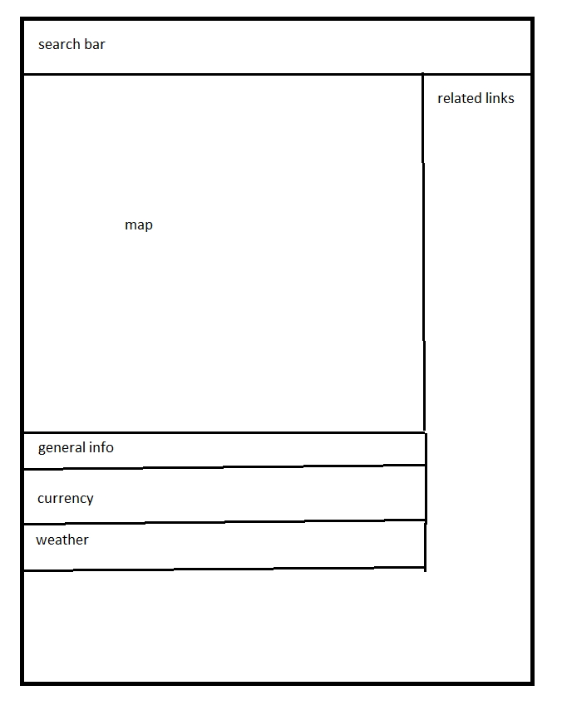

by default the page will load the user country and nearest city data, from there the user can choose to select another country and city to display (if he only selects a country it will display information about the capital city).

Info tabs (general info/ currency/ weather)
The user will be able to expand this 3 tabs to view additional infor mation:

The General info tab will contain some information about the country and selected city like population, currency, language etc..

The Currency tab will display a basic currency converter between a base currency and the selected country's currency. It will also display a graph showing the currency changes in the last days.

The Weather tab will display the current weather of the displayed city and a table showing the weather of the last 7 days.

Process Flow

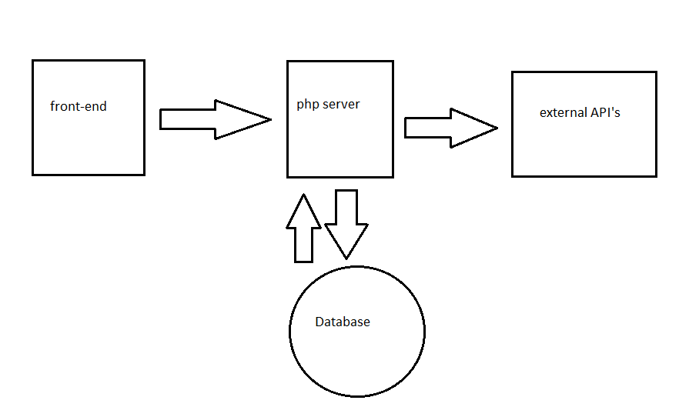
For every request from the FRONT-END the PHP server will first look for the data in the Database, if it doesn't find the data then it will call the external API's, save the received data and pass it to the front-end.

Database Tables Structure

